SIMATS ENGINEERING (SAVEETHA SCHOOL OF ENGINEERING)

Department of Artificial Intelligence and Data Science CO1 – ASSESSMENT TOOL 1 – APPLICATION BASED QUESTIONS

Course Code: | DSA03 | Course Title: | Natural Language Processing
CO Assessed: | CO1 – Imitation (L1) | Assessment: | Assessment Tool 1 – Application Based Questions
Student Name: | T Mubeena | Reg. No.: | 192425295
Section / Batch: | 2023 batch | Date: | 10-10-2026

CO1 Statement: Analyse NLP models, regular expression patterns, finite state automata, morphological processing techniques and to interpret language processing. (BL-3)
Code of Conduct: I TMubeena (192425295) (Name / Reg No) certify that this submission is my original work and that I have adhered to the guidelines specified for this assessment.
Signature of the Student: Mubeena

Question 1: Resume Information Extraction System

Problem Statement
Design and implement a Python-based resume information extraction system using Regular Expressions that extracts the candidate's name, email addresses, mobile numbers, technical skills (Python, Java, SQL, Machine Learning, NLP) and years of experience, generates a structured profile summary, and displays candidates who satisfy the minimum eligibility criteria (at least 2 years of experience and Python skill).

Approach
- Each field is extracted by its own small function using a pre-compiled regular expression (modular design).
- build_profile() combines all extractors into one structured dictionary for each resume.
- is_eligible() applies the shortlisting rule: experience >= 2 years AND "Python" in the skill list.
- Mobile numbers are normalised to plain 10-digit form; empty or invalid resume input raises a ValueError.

Regular Expression Patterns Used

Field | Pattern | Explanation
Name | ^\s*(?:Name\s*[:\-]\s*)?([A-Z][a-  z]+(?:\s+[A-Z][a-z]*\.?){1,3})\s*$ | Optional "Name:" label followed by 2–4 capitalised words on a line of their own
Email | \b[A-Za-z0-9._%+-]+@[A-Za-z0-9.-]+\.[A-  Za-z]{2,}\b | username, @, domain, dot, TLD of 2+ letters
Mobile | (?<!\d)(?:\+91[\s-]?|0)?([6-9]\d{4}[\s-  ]?\d{5})(?!\d) | Indian mobile: optional +91  / 0, first digit 6–9, 10 digits in total
Skills | \bSkill\b (re.IGNORECASE) | Word boundary stops "Java" matching inside "JavaScript"
Experience | (\d+(?:\.\d+)?)\s*\+?\s*(?:years?|yrs?)\b | Integer or decimal number followed by year / years / yr / yrs

Python Program
"""
Q1 - Resume Information Extraction System (Regular Expressions) """
import re

# ---------- Compiled regular expression patterns ----------
NAME_PATTERN = re.compile(r"^\s*(?:Name\s*[:\-]\s*)?([A-Z][a-z]+(?:\s+[A-Z][a-z]*\.?){1,3})\s*$", re.MULTILINE)
EMAIL_PATTERN = re.compile(r"\b[A-Za-z0-9._%+-]+@[A-Za-z0-9.-]+\.[A-Za-z]{2,}\b")
MOBILE_PATTERN = re.compile(r"(?<!\d)(?:\+91[\s-]?|0)?([6-9]\d{4}[\s-]?\d{5})(?!\d)") EXP_PATTERN = re.compile(r"(\d+(?:\.\d+)?)\s*\+?\s*(?:years?|yrs?)\b", re.IGNORECASE)

SKILLS = ["Python", "Java", "SQL", "Machine Learning", "NLP"] # \b prevents "Java" matching inside "JavaScript"
SKILL_PATTERNS = {s: re.compile(r"\b" + re.escape(s) + r"\b", re.IGNORECASE) for s in SKILLS}

def extract_name(text):
m = NAME_PATTERN.search(text)
return m.group(1).strip() if m else "Not found"

def extract_emails(text):
return EMAIL_PATTERN.findall(text)

def extract_mobiles(text):
# normalise to a plain 10-digit number
return [re.sub(r"[\s-]", "", n) for n in MOBILE_PATTERN.findall(text)]

def extract_skills(text):
return [skill for skill, pat in SKILL_PATTERNS.items() if pat.search(text)]

def extract_experience(text):
years = [float(y) for y in EXP_PATTERN.findall(text)] return max(years) if years else 0.0

def build_profile(resume_text):
"""Return a structured dictionary summarising one resume."""
if not isinstance(resume_text, str) or not resume_text.strip(): raise ValueError("Resume text is empty or invalid")
return {
"name": extract_name(resume_text), "emails": extract_emails(resume_text), "mobiles": extract_mobiles(resume_text), "skills": extract_skills(resume_text),
"experience": extract_experience(resume_text),
}

def is_eligible(profile, min_exp=2, required_skill="Python"):
return profile["experience"] >= min_exp and required_skill in profile["skills"]

def print_profile(profile): print("-" * 55)
print(f"Name : {profile['name']}")
print(f"Email : {', '.join(profile['emails']) or 'Not found'}")
print(f"Mobile : {', '.join(profile['mobiles']) or 'Not found'}")
print(f"Skills : {', '.join(profile['skills']) or 'None detected'}") print(f"Experience : {profile['experience']:g} year(s)") print(f"Eligible : {'YES' if is_eligible(profile) else 'NO'}")

if name == " main ": resumes = [
"""Rahul Sharma Email: rahul.sharma@gmail.com Mobile: +91 98765 43210
Skills: Python, SQL, Machine Learning, NLP Experience: 3 years as Data Scientist""",

"""Name: Priya Nair
Contact: priya.nair@outlook.com | 9123456780 Technical Skills: Java, SQL, JavaScript
Total experience of 5 years in backend development""",

"""Arun Kumar

arun_k@yahoo.co.in Phone: 91234-56789
Skills: python, nlp
Fresher with 1 year internship experience""",

"""Sneha Reddy sneha.reddy@company.org
+91-8012345678
Expertise: Python, Java, Machine Learning Experience: 2.5 yrs in AI development""",
]

profiles = []
for idx, resume in enumerate(resumes, start=1): print(f"\nCANDIDATE {idx}")
try:
profile = build_profile(resume) profiles.append(profile) print_profile(profile)
except ValueError as err: print("Error:", err)

print("\n" + "=" * 55)
print("SHORTLISTED CANDIDATES (>= 2 years experience AND Python)") print("=" * 55)
shortlisted = [p for p in profiles if is_eligible(p)] for p in shortlisted:
print(f"* {p['name']:<15} | {p['experience']:g} yrs | {', '.join(p['skills'])}")
print(f"\nTotal shortlisted: {len(shortlisted)} of {len(profiles)}")

# Error-handling test print("\nEmpty-resume test:") try:
build_profile(" ") except ValueError as err:
print("Error:", err)

Output

CANDIDATE 1
Name | : | Rahul Sharma
Email | : | rahul.sharma@gmail.com
Mobile | : | 9876543210
Skills | : | Python, SQL, Machine Learning, NLP
Experience | : | 3 year(s)
Eligible | : | YES
CANDIDATE 2
Name | : | Priya Nair
Email | : | priya.nair@outlook.com
Mobile | : | 9123456780
Skills | : | Java, SQL
Experience | : | 5 year(s)
Eligible | : | NO
CANDIDATE 3
Name | : | Arun Kumar
Email | : | arun_k@yahoo.co.in
Mobile | : | 9123456789
Skills | : | Python, NLP
Experience | : | 1 year(s)
Eligible | : | NO
CANDIDATE 4
Name | : | Sneha Reddy
Email | : | sneha.reddy@company.org

Mobile
: 8012345678
Skills : Python, Java, Machine Learning Experience : 2.5 year(s)
Eligible : YES

=======================================================
SHORTLISTED CANDIDATES (>= 2 years experience AND Python)
=======================================================
- Rahul Sharma | 3 yrs | Python, SQL, Machine Learning, NLP
- Sneha Reddy | 2.5 yrs | Python, Java, Machine Learning Total shortlisted: 2 of 4
Empty-resume test:
Error: Resume text is empty or invalid

Test Cases and Justification

Test Case | Input Highlights | Result / Justification
Candidate 1 | Python, SQL, ML, NLP; 3 years; +91 98765 43210 | Shortlisted. Experience 3 >= 2 and Python present. The +91 and spaces are stripped to give 9876543210.
Candidate 2 | Java, SQL, JavaScript; 5 years | Not shortlisted. Experience is enough but Python is missing. JavaScript is correctly not counted as Java thanks to \b.
Candidate 3 | python, nlp (lower case); 1 year | Not shortlisted. Lower-case skills are still detected (IGNORECASE) but 1 year  < 2 years.
Candidate 4 | Python, Java, ML; 2.5 yrs | Shortlisted. The decimal 2.5 and abbreviation "yrs" are handled by the experience pattern.
Empty resume | " " | ValueError raised and displayed, so the program does not crash.

Conclusion: 2 of 4 candidates (Rahul Sharma and Sneha Reddy) satisfy the eligibility criteria. The output matches the expected result for every test case, which confirms that the extraction and filtering logic is correct.

Question 2: Product Search System

Problem Statement
Design and implement a Python-based product search system using Regular Expressions that supports exact, prefix, suffix, partial and case-insensitive searches, displays all matching product names, and generates a report with the number of matches for each search.

Approach
- build_pattern() creates the regex for the chosen mode; search() compiles it and filters the product list.
- re.escape() is applied to the keyword so special characters typed by the user are matched literally and cannot break the pattern.
- Case-insensitivity is controlled by a flag (re.IGNORECASE), so the same patterns work for both cases.
- run_searches() prints the matches and collects counts; print_report() displays the final summary table.

Regular Expression Patterns Used

Search Type | Pattern | Meaning
Exact | ^keyword$ | Whole product name must equal the keyword
Prefix | \bkeyword\w* | A word in the name begins with the keyword (e.g. Smart -> Smartphone)
Suffix | \w*keyword\b | A word in the name ends with the keyword (e.g. phone  -> Headphone)
Partial | keyword | Keyword appears anywhere in the name
Case-insensitive | re.IGNORECASE flag | Upper and lower case treated as the same

Python Program
"""
Q2 - Product Search System (Regular Expressions) """
import re

PRODUCTS = [
"Laptop", "Laptop Bag", "Gaming Laptop", "Wireless Mouse", "Mouse Pad", "Mechanical Keyboard", "Keyboard Cover", "Smartphone", "Smartwatch", "Phone Case", "Headphones", "Bluetooth Headphone", "Earphones",
"USB Cable", "USB Charger", "Power Bank", "Laptop Stand", "Webcam", "Tablet", "Tablet Cover",
]
def build_pattern(keyword, mode):
"""Return a compiled regex for the requested search mode.""" if not keyword or not keyword.strip():
raise ValueError("Search keyword cannot be empty")
kw = re.escape(keyword.strip()) patterns = {
"exact": rf"^{kw}$",
"prefix": rf"\b{kw}\w*",
"suffix": rf"\w*{kw}\b",
"partial": rf"{kw}",
}
# treat user input literally
# whole product name equals keyword # a word starting with keyword
# a word ending with keyword # keyword anywhere
if mode not in patterns:
raise ValueError(f"Unknown search mode: {mode}")

return patterns[mode]
def search(products, keyword, mode="partial", ignore_case=True): flags = re.IGNORECASE if ignore_case else 0
pattern = re.compile(build_pattern(keyword, mode), flags) return [p for p in products if pattern.search(p)]
def run_searches(products, queries): report = []
for keyword, mode, ignore_case in queries:
label = f"{mode.upper()} | keyword='{keyword}' | case-{'insensitive' if ignore_case else 'sensitive'}"
print("\n" + label) try:
matches = search(products, keyword, mode, ignore_case) except ValueError as err:
print(" Error:", err) report.append((label, None)) continue
if matches:
for m in matches: print(" -", m)
else:
print(" No matching products found") report.append((label, len(matches)))
return report
def print_report(report): print("\n" + "=" * 70) print("SEARCH REPORT")
print("=" * 70) print(f"{'Search':<55}{'Matches':>8}") print("-" * 70)
for label, count in report:
print(f"{label:<55}{('ERR' if count is None else count):>8}")
if name == " main ": queries = [
("Laptop",
("laptop",
("Smart",
("Cover",
("phone",
("board",
("LAPTOP",
("LAPTOP",
("",
("xyz",
"exact", False),
"exact", True),
"prefix", True),
"suffix", True),
"suffix", True),
"partial", True), "partial", False), "partial", True),
"partial", True),
"partial", True),
# exact keyword
# exact, case-insensitive # prefix
# suffix
# suffix (word ends with 'phone') # partial keyword
# case-sensitive -> 0 matches # case-insensitive -> matches # error handling
# no result
]
print_report(run_searches(PRODUCTS, queries))

Output
EXACT | keyword='Laptop' | case-sensitive
- Laptop

EXACT | keyword='laptop' | case-insensitive
- Laptop

PREFIX | keyword='Smart' | case-insensitive
- Smartphone
- Smartwatch

SUFFIX | keyword='Cover' | case-insensitive
- Keyboard Cover

SUFFIX | keyword='Cover' | case-insensitive | 2
SUFFIX | keyword='phone' | case-insensitive | 3
PARTIAL | keyword='board' | case-insensitive | 2
PARTIAL | keyword='LAPTOP' | case-sensitive | 0
PARTIAL | keyword='LAPTOP' | case-insensitive | 4
PARTIAL | keyword='' | case-insensitive | ERR
PARTIAL | keyword='xyz' | case-insensitive | 0

Test Cases and Justification
- Tablet Cover

SUFFIX | keyword='phone' | case-insensitive
- Smartphone
- Phone Case
- Bluetooth Headphone

PARTIAL | keyword='board' | case-insensitive
- Mechanical Keyboard
- Keyboard Cover

PARTIAL | keyword='LAPTOP' | case-sensitive No matching products found

PARTIAL | keyword='LAPTOP' | case-insensitive
- Laptop
- Laptop Bag
- Gaming Laptop
- Laptop Stand

PARTIAL | keyword='' | case-insensitive Error: Search keyword cannot be empty

PARTIAL | keyword='xyz' | case-insensitive No matching products found

====================================================================== SEARCH REPORT
======================================================================
Search Matches
EXACT | keyword='Laptop' | case-sensitive EXACT | keyword='laptop' | case-insensitive PREFIX | keyword='Smart' | case-insensitive
1
1
2

Search | Matches | Justification
Exact "Laptop" | 1 | Only the product named exactly "Laptop"; Laptop Bag, Gaming Laptop, etc. are excluded by ^ and $.
Prefix "Smart" | 2 | Smartphone and Smartwatch begin with "Smart".
Suffix "Cover" | 2 | Keyboard Cover and Tablet Cover end with "Cover".
Suffix "phone" | 3 | Smartphone, Phone Case (case-insensitive) and Bluetooth Headphone. "Headphones" and "Earphones" are not counted because the word ends with "s", not "phone".
Partial "board" | 2 | Found inside Keyboard in both Mechanical Keyboard and Keyboard Cover.
"LAPTOP" case-sensitive | 0 | Capitals do not match the stored "Laptop", which proves case-sensitive mode works.
"LAPTOP" case-insensitive | 4 | With IGNORECASE all four laptop-related products are found.

Search | Matches | Justification
Empty keyword | Error | ValueError is caught and shown instead of crashing.
"xyz" | 0 | A clear "No matching products found" message is displayed.

Conclusion: All search types return the expected products and the report shows the correct count for every search, so the system meets all the stated requirements.

Question 3: University Registration Validation System

Problem Statement
Design and implement a Python-based validation system using Regular Expressions that validates the student register number, institutional email, course code, semester and mobile number, displays a validation message for each field, and produces a final registration status report.

Approach
- All rules are stored in one dictionary (field -> compiled pattern + format hint), so a rule can be changed without touching the logic.
- re.fullmatch() is used so the whole input must follow the format (no extra characters before or after).
- validate_field() returns (True/False, message); validate_registration() checks all fields; print_report() shows PASS/FAIL per field.
- Registration is successful only if every field is valid. Empty values are detected and reported separately.

Regular Expression Patterns Used

Field | Pattern | Valid Format
Register Number | 19(?:2[0-5])\d{5} | 9 digits: institute code 19 + year 20–25 + 5-digit serial (e.g.  192311234)
Institutional Email | [A-Za-z0-9._%+-  ]+@(?:saveetha\.com|simats\.edu\.in) | Username with an institutional domain only
Course Code | [A-Z]{3}\d{2} | 3 capital letters + 2 digits (e.g. DSA03)
Semester | [1-8] | Single digit 1 to 8
Mobile Number | (?:\+91[\s-]?)?[6-9]\d{9} | 10 digits starting with 6–9,  optional +91

Note: The register number and domain formats are assumed typical institutional formats because the question does not specify them. They can be changed in the RULES dictionary.

Python Program
"""
Q3 - University Registration Validation System (Regular Expressions) """
import re

# ---------- Validation rules (assumed institutional formats) ----------RULES = {
# 9 digits: '19' institute code + 2-digit year (20-25) + 5-digit serial e.g.
192311234
"Register Number": (re.compile(r"19(?:2[0-5])\d{5}"),
"9 digits, e.g. 192311234"), # username @ saveetha.com or simats.edu.in
"Institutional Email": (re.compile(r"[A-Za-z0-9._%+-
]+@(?:saveetha\.com|simats\.edu\.in)", re.IGNORECASE),
"must end with @saveetha.com or @simats.edu.in"), # 3 capital letters + 2 digits e.g. DSA03
"Course Code": (re.compile(r"[A-Z]{3}\d{2}"),
"3 capital letters + 2 digits, e.g. DSA03"), # semester 1 to 8

"Semester": (re.compile(r"[1-8]"),
"a single digit from 1 to 8"),
# Indian mobile: optional +91, starts with 6-9, 10 digits "Mobile Number": (re.compile(r"(?:\+91[\s-]?)?[6-9]\d{9}"),
"10 digits starting with 6-9, optional +91"),
}

def validate_field(field, value):
"""Return (is_valid, message) for one field using re.fullmatch.""" pattern, hint = RULES[field]
if value is None or not str(value).strip():
return False, f"INVALID - field is empty ({hint})" if pattern.fullmatch(str(value).strip()):
return True, "VALID"
return False, f"INVALID - {hint}"

def validate_registration(student): results = {}
for field in RULES:
results[field] = validate_field(field, student.get(field)) return results

def print_report(student, results): print("-" * 66)
for field, (ok, msg) in results.items(): mark = "[PASS]" if ok else "[FAIL]"
print(f"{mark} {field:<20}: {student.get(field)!s:<24} -> {msg}") status = all(ok for ok, _ in results.values())
print("-" * 66)
print("REGISTRATION STATUS:", "SUCCESSFUL" if status else "REJECTED")
return status

if name == " main ": students = [
("Test Case 1 - All valid", {
"Register Number": "192311234", "Institutional Email": "rahul.s@saveetha.com",
"Course Code": "DSA03", "Semester": "5", "Mobile Number": "+91 9876543210"}),
("Test Case 2 - Multiple errors", {
"Register Number": "12345", "Institutional Email": "rahul@gmail.com", "Course Code": "dsa3", "Semester": "9", "Mobile Number": "1234567890"}),
("Test Case 3 - One error (semester)", {
"Register Number": "192411567", "Institutional Email": "priya_n@simats.edu.in",
"Course Code": "CSE45", "Semester": "0", "Mobile Number": "9123456780"}), ("Test Case 4 - Empty fields", {
"Register Number": "", "Institutional Email": "", "Course Code": "DSA03", "Semester": "", "Mobile Number": "98765"}),
]
summary = []
for title, data in students: print("\n" + title)
summary.append((title, print_report(data, validate_registration(data))))

print("\n" + "=" * 66) print("FINAL SUMMARY")
for title, ok in summary:
print(f"{title:<40}: {'SUCCESSFUL' if ok else 'REJECTED'}")

Output
Test Case 1 - All valid
[PASS] Register Number
: 192311234
[PASS] Institutional Email : rahul.s@saveetha.com
-> VALID
-> VALID

[PASS] Course Code : DSA03 -> VALID
[PASS] Semester : 5 -> VALID [PASS] Mobile Number : +91 9876543210 -> VALID
REGISTRATION STATUS: SUCCESSFUL

Test Case 2 - Multiple errors
[FAIL] Register Number : 12345 -> INVALID - 9 digits, e.g. 192311234
[FAIL] Institutional Email : rahul@gmail.com -> INVALID - must end with @saveetha.com or @simats.edu.in
[FAIL] Course Code : dsa3 -> INVALID - 3 capital letters +
2 digits, e.g. DSA03
[FAIL] Semester : 9 -> INVALID - a single digit from
1 to 8
[FAIL] Mobile Number : 1234567890 -> INVALID - 10 digits starting with 6-9, optional +91
REGISTRATION STATUS: REJECTED

Test Case 3 - One error (semester)
[PASS] Register Number : 192411567 -> VALID [PASS] Institutional Email : priya_n@simats.edu.in -> VALID [PASS] Course Code : CSE45 -> VALID
[FAIL] Semester : 0 -> INVALID - a single digit from
1 to 8
[PASS] Mobile Number : 9123456780 -> VALID
REGISTRATION STATUS: REJECTED

Test Case 4 - Empty fields
[FAIL] Register Number : -> INVALID - field is empty (9 digits, e.g. 192311234)
[FAIL] Institutional Email : -> INVALID - field is empty (must end with @saveetha.com or @simats.edu.in)
[PASS] Course Code : DSA03 -> VALID
[FAIL] Semester : -> INVALID - field is empty (a single digit from 1 to 8)
[FAIL] Mobile Number : 98765 -> INVALID - 10 digits starting with 6-9, optional +91
REGISTRATION STATUS: REJECTED

================================================================== FINAL SUMMARY
Test Case 1 - All valid : SUCCESSFUL
Test Case 2 - Multiple errors : REJECTED Test Case 3 - One error (semester) : REJECTED
Test Case 4 - Empty fields : REJECTED

Test Cases and Justification

Test Case | Status | Justification
1 – All valid | SUCCESSFUL | Every field matches its pattern; +91 and the space are allowed in the mobile number.
2 – Multiple errors | REJECTED | Register number too short, Gmail domain, lower-case course code, semester 9 and mobile starting with 1 all fail.
3 – One error | REJECTED | Four fields are valid but semester 0 is outside 1–8, so a single failure rejects the registration.

Test Case | Status | Justification
4 – Empty fields | REJECTED | Empty inputs get a specific "field is empty" message; the short mobile number 98765 also fails.

Conclusion: The validator accepts only correctly formatted data, gives a clear message for each field, and the final report correctly marks only Test Case 1 as successful.

Part B: Graphical User Interface (GUI) Implementation

Overview
The three systems above were also combined into a single desktop application using Python's built-in Tkinter library. The GUI uses exactly the same regular expressions and validation logic; only the input and output are moved from the console to windows, buttons and tables, which makes the system easier to use for HR staff, customers and students.

GUI Design
- A tabbed window (ttk.Notebook) holds one tab for each question.
- Tab 1 - Resume Extraction: a text box for resumes, an Extract button, a results table with eligible candidates highlighted green, and a shortlist summary.
- Tab 2 - Product Search: keyword box, search-type drop-down (Exact / Prefix / Suffix / Partial), an Ignore-case check box, a results list and a running search report table.
- Tab 3 - Registration Validation: a form with five fields, a tick or cross beside each field, a coloured SUCCESSFUL / REJECTED banner and a detailed report.
- Error handling: message boxes for empty input or an empty keyword; invalid form data is reported field by field.

GUI Screenshots
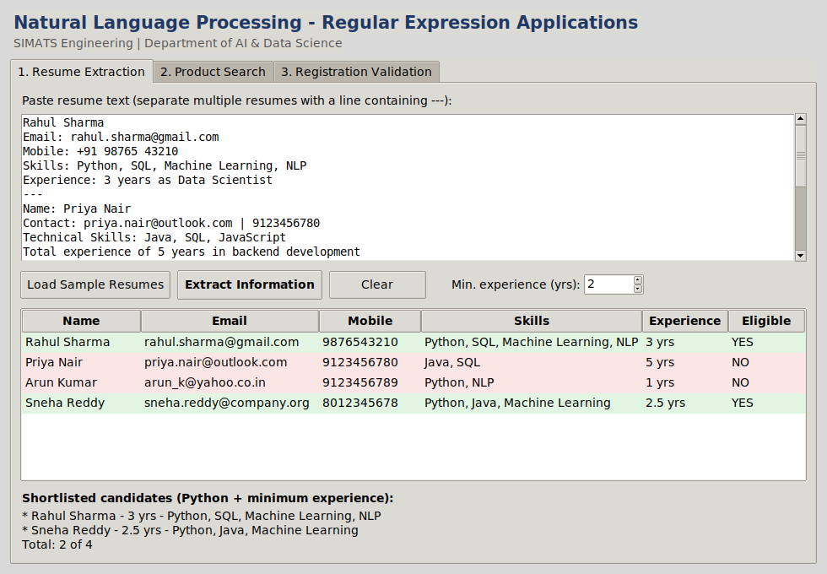

Figure 1: Resume Extraction tab - 2 of 4 candidates shortlisted

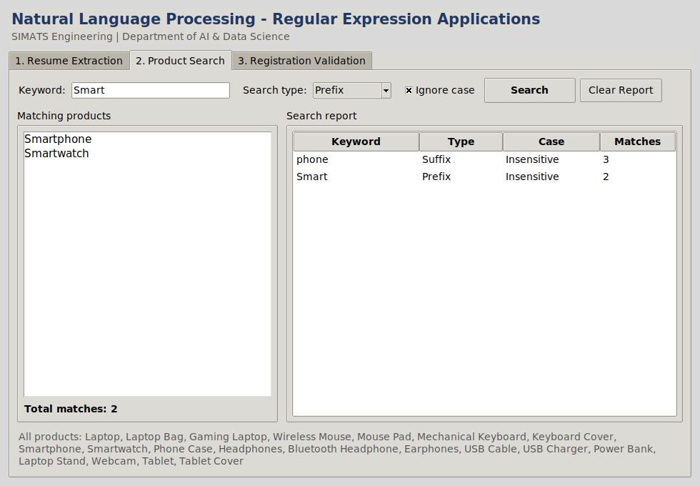

Figure 2: Product Search tab - prefix and suffix searches with report
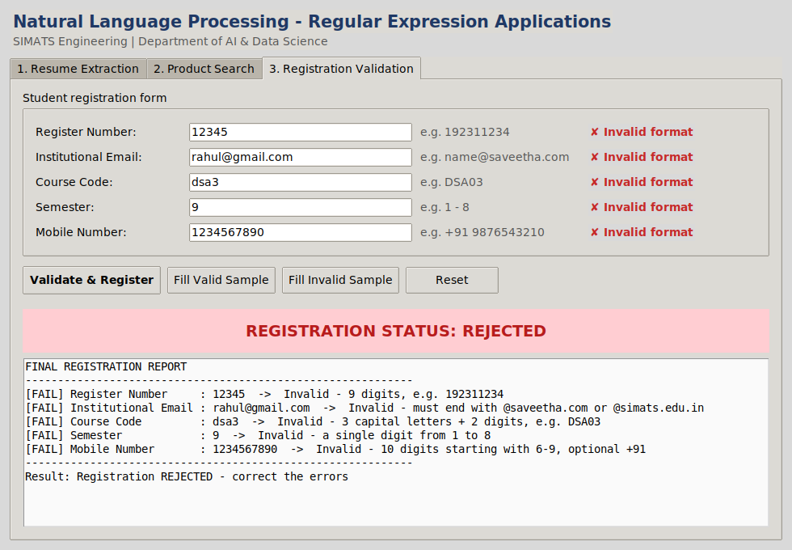

Figure 3: Registration Validation tab - invalid data rejected

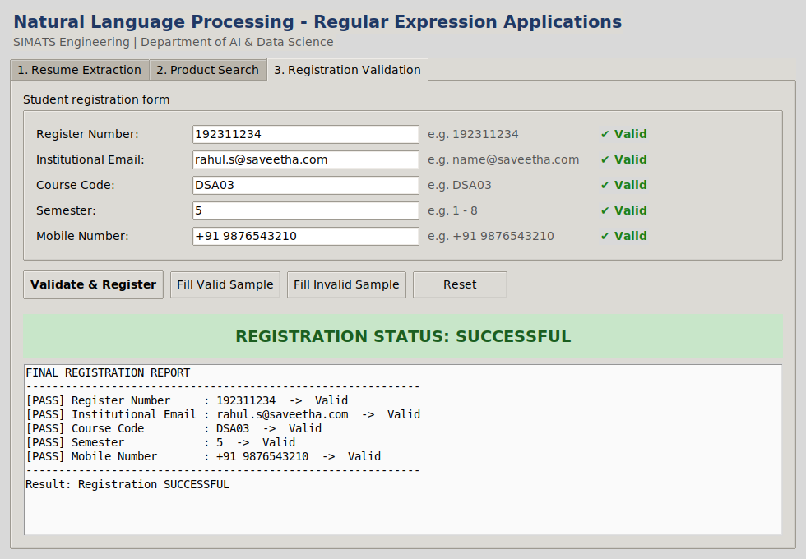
Figure 4: Registration Validation tab - valid data accepted

Test Cases and Justification

GUI Action | Input | Observed Result
Load Sample + Extract | 4 sample resumes | Table shows 4 candidates; Rahul Sharma and Sneha Reddy highlighted green (shortlisted), total 2 of 4.
Product search | Keyword "phone", Suffix, Ignore case | 3 matches (Smartphone, Phone Case, Bluetooth Headphone) added to the report.
Product search | Keyword "Smart", Prefix | 2 matches (Smartphone, Smartwatch); the report table now has two rows.
Fill Invalid Sample + Validate | All five fields incorrect | Each field marked with a red cross; banner shows REJECTED.
Fill Valid Sample + Validate | All five fields correct | Each field marked with a green tick; banner shows SUCCESSFUL.

Conclusion: The GUI gives the same results as the console programs for all test cases, confirming that the regular-expression logic is correct and that the interface presents it clearly.

GUI Python Program
"""
DSA03 - NLP | CO1 Assessment Tool 1 GUI application (Tkinter) for:
Tab 1 - Resume Information Extraction Tab 2 - Product Search System
Tab 3 - University Registration Validation Run: python nlp_gui.py
"""

import re
import tkinter as tk
from tkinter import ttk, messagebox

# =====================================================================
# Q1 LOGIC - Resume extraction
# =====================================================================
NAME_PATTERN = re.compile(r"^\s*(?:Name\s*[:\-]\s*)?([A-Z][a-z]+(?:\s+[A-Z][a-z]*\.?){1,3})\s*$", re.MULTILINE)
EMAIL_PATTERN = re.compile(r"\b[A-Za-z0-9._%+-]+@[A-Za-z0-9.-]+\.[A-Za-z]{2,}\b")
MOBILE_PATTERN = re.compile(r"(?<!\d)(?:\+91[\s-]?|0)?([6-9]\d{4}[\s-]?\d{5})(?!\d)") EXP_PATTERN = re.compile(r"(\d+(?:\.\d+)?)\s*\+?\s*(?:years?|yrs?)\b", re.IGNORECASE) SKILLS = ["Python", "Java", "SQL", "Machine Learning", "NLP"]
SKILL_PATTERNS = {s: re.compile(r"\b" + re.escape(s) + r"\b", re.IGNORECASE) for s in SKILLS}

def build_profile(text):
if not text or not text.strip():
raise ValueError("Resume text is empty") m = NAME_PATTERN.search(text)
years = [float(y) for y in EXP_PATTERN.findall(text)] return {
"name": m.group(1).strip() if m else "Not found", "emails": EMAIL_PATTERN.findall(text),
"mobiles": [re.sub(r"[\s-]", "", n) for n in MOBILE_PATTERN.findall(text)], "skills": [s for s, p in SKILL_PATTERNS.items() if p.search(text)], "experience": max(years) if years else 0.0,
}

def is_eligible(profile, min_exp=2, skill="Python"):
return profile["experience"] >= min_exp and skill in profile["skills"]

SAMPLE_RESUMES = """Rahul Sharma Email: rahul.sharma@gmail.com Mobile: +91 98765 43210
Skills: Python, SQL, Machine Learning, NLP Experience: 3 years as Data Scientist
---
Name: Priya Nair
Contact: priya.nair@outlook.com | 9123456780 Technical Skills: Java, SQL, JavaScript
Total experience of 5 years in backend development
---
Arun Kumar arun_k@yahoo.co.in Phone: 91234-56789
Skills: python, nlp
Fresher with 1 year internship experience
---
Sneha Reddy sneha.reddy@company.org
+91-8012345678
Expertise: Python, Java, Machine Learning Experience: 2.5 yrs in AI development"""

# =====================================================================
# Q2 LOGIC - Product search
# ===================================================================== PRODUCTS = [
"Laptop", "Laptop Bag", "Gaming Laptop", "Wireless Mouse", "Mouse Pad", "Mechanical Keyboard", "Keyboard Cover", "Smartphone", "Smartwatch", "Phone Case", "Headphones", "Bluetooth Headphone", "Earphones",
"USB Cable", "USB Charger", "Power Bank", "Laptop Stand", "Webcam", "Tablet", "Tablet Cover",
]

def search_products(keyword, mode, ignore_case): if not keyword.strip():
raise ValueError("Search keyword cannot be empty") kw = re.escape(keyword.strip())
pattern = {"Exact": rf"^{kw}$", "Prefix": rf"\b{kw}\w*",
"Suffix": rf"\w*{kw}\b", "Partial": kw}[mode]
rx = re.compile(pattern, re.IGNORECASE if ignore_case else 0) return [p for p in PRODUCTS if rx.search(p)]

# =====================================================================
# Q3 LOGIC - Registration validation
# ===================================================================== RULES = {
"Register Number": (re.compile(r"19(?:2[0-5])\d{5}"), "9 digits, e.g. 192311234"), "Institutional Email": (re.compile(r"[A-Za-z0-9._%+-
]+@(?:saveetha\.com|simats\.edu\.in)", re.I),
"must end with @saveetha.com or @simats.edu.in"), "Course Code": (re.compile(r"[A-Z]{3}\d{2}"), "3 capital letters + 2 digits, e.g.
DSA03"),
"Semester": (re.compile(r"[1-8]"), "a single digit from 1 to 8"),
"Mobile Number": (re.compile(r"(?:\+91[\s-]?)?[6-9]\d{9}"), "10 digits starting with 6-9, optional +91"),
}

def validate_field(field, value): pattern, hint = RULES[field] value = value.strip()
if not value:
return False, f"Field is empty ({hint})" if pattern.fullmatch(value):
return True, "Valid"
return False, f"Invalid - {hint}"

# ===================================================================== # GUI
# =====================================================================
class App(tk.Tk):
def init (self): super(). init ()
self.title("DSA03 - NLP | CO1 Assessment Tool 1") self.geometry("980x680")
self.minsize(860, 600) style = ttk.Style(self) style.theme_use("clam")
style.configure("Title.TLabel", font=("Segoe UI", 15, "bold"), foreground="#1F3864")
style.configure("Sub.TLabel", font=("Segoe UI", 10), foreground="#555555") style.configure("Accent.TButton", font=("Segoe UI", 10, "bold"), padding=6) style.configure("Treeview", rowheight=24, font=("Segoe UI", 10)) style.configure("Treeview.Heading", font=("Segoe UI", 10, "bold"))

ttk.Label(self, text="Natural Language Processing - Regular Expression Applications",
style="Title.TLabel").pack(anchor="w", padx=14, pady=(12, 0)) ttk.Label(self, text="SIMATS Engineering | Department of AI & Data Science",
style="Sub.TLabel").pack(anchor="w", padx=14, pady=(0, 8))

nb = ttk.Notebook(self)
nb.pack(fill="both", expand=True, padx=12, pady=(0, 12)) self.build_resume_tab(nb)
self.build_search_tab(nb) self.build_register_tab(nb)

# Tab 1
def build_resume_tab(self, nb):

f = ttk.Frame(nb, padding=10) nb.add(f, text="1. Resume Extraction")

ttk.Label(f, text="Paste resume text (separate multiple resumes with a line containing ---):").pack(anchor="w")
box = ttk.Frame(f) box.pack(fill="x", pady=4)
self.resume_text = tk.Text(box, height=10, font=("Consolas", 10), wrap="word") sb = ttk.Scrollbar(box, command=self.resume_text.yview) self.resume_text.configure(yscrollcommand=sb.set) self.resume_text.pack(side="left", fill="x", expand=True) sb.pack(side="right", fill="y")

bar = ttk.Frame(f) bar.pack(fill="x", pady=6)
ttk.Button(bar, text="Load Sample Resumes", command=self.load_sample).pack(side="left")
ttk.Button(bar, text="Extract Information", style="Accent.TButton", command=self.extract_resumes).pack(side="left", padx=8)
ttk.Button(bar, text="Clear", command=self.clear_resumes).pack(side="left") self.min_exp = tk.DoubleVar(value=2)
ttk.Label(bar, text=" Min. experience (yrs):").pack(side="left", padx=(20, 2)) ttk.Spinbox(bar, from_=0, to=30, increment=0.5, width=5,
textvariable=self.min_exp).pack(side="left")

cols = ("Name", "Email", "Mobile", "Skills", "Experience", "Eligible") widths = (120, 190, 100, 240, 80, 70)
self.res_tree = ttk.Treeview(f, columns=cols, show="headings", height=7) for c, w in zip(cols, widths):
self.res_tree.heading(c, text=c) self.res_tree.column(c, width=w, anchor="w")
self.res_tree.tag_configure("yes", background="#E2F4E2") self.res_tree.tag_configure("no", background="#FBE5E5") self.res_tree.pack(fill="both", expand=True, pady=4)

ttk.Label(f, text="Shortlisted candidates (Python + minimum experience):", font=("Segoe UI", 10, "bold")).pack(anchor="w", pady=(6, 0))
self.short_label = ttk.Label(f, text="-", justify="left", wraplength=900) self.short_label.pack(anchor="w")

def load_sample(self): self.resume_text.delete("1.0", "end") self.resume_text.insert("1.0", SAMPLE_RESUMES)

def clear_resumes(self): self.resume_text.delete("1.0", "end")
self.res_tree.delete(*self.res_tree.get_children()) self.short_label.config(text="-")

def extract_resumes(self):
raw = self.resume_text.get("1.0", "end")
blocks = [b for b in re.split(r"^\s*-{3,}\s*$", raw, flags=re.MULTILINE) if b.strip()]
if not blocks:
messagebox.showwarning("No input", "Please paste at least one resume or load the samples.")
return self.res_tree.delete(*self.res_tree.get_children()) try:
min_exp = float(self.min_exp.get()) except tk.TclError:
messagebox.showerror("Invalid value", "Minimum experience must be a
number.")
return
shortlisted = [] for block in blocks:
p = build_profile(block)
ok = is_eligible(p, min_exp) if ok:
shortlisted.append(p)
self.res_tree.insert("", "end", tags=("yes" if ok else "no",), values=(

",
else "NO"))
p["name"], ", ".join(p["emails"]) or "-", ", ".join(p["mobiles"]) or "-
", ".join(p["skills"]) or "-", f"{p['experience']:g} yrs", "YES" if ok

if shortlisted:
lines = [f"* {p['name']} - {p['experience']:g} yrs - {', '.join(p['skills'])}" for p in shortlisted]
self.short_label.config(text="\n".join(lines) + f"\nTotal:
{len(shortlisted)} of {len(blocks)}") else:
self.short_label.config(text=f"No candidate meets the criteria (0 of
{len(blocks)})")

# Tab 2
def build_search_tab(self, nb): f = ttk.Frame(nb, padding=10)
nb.add(f, text="2. Product Search")

bar = ttk.Frame(f) bar.pack(fill="x")
ttk.Label(bar, text="Keyword:").pack(side="left") self.kw = tk.StringVar()
e = ttk.Entry(bar, textvariable=self.kw, width=24) e.pack(side="left", padx=6)
e.bind("<Return>", lambda _e: self.run_search())
ttk.Label(bar, text="Search type:").pack(side="left", padx=(10, 0)) self.mode = tk.StringVar(value="Partial")
ttk.Combobox(bar, textvariable=self.mode, values=["Exact", "Prefix", "Suffix", "Partial"],
width=10, state="readonly").pack(side="left", padx=6) self.ignore_case = tk.BooleanVar(value=True)
ttk.Checkbutton(bar, text="Ignore case", variable=self.ignore_case).pack(side="left", padx=10)
ttk.Button(bar, text="Search", style="Accent.TButton", command=self.run_search).pack(side="left")
ttk.Button(bar, text="Clear Report", command=self.clear_report).pack(side="left", padx=6)

mid = ttk.Frame(f)
mid.pack(fill="both", expand=True, pady=10)

left = ttk.LabelFrame(mid, text="Matching products", padding=6) left.pack(side="left", fill="both", expand=True, padx=(0, 6)) self.result_list = tk.Listbox(left, font=("Segoe UI", 11), activestyle="none") self.result_list.pack(fill="both", expand=True)
self.count_label = ttk.Label(left, text="Total matches: -", font=("Segoe UI", 10, "bold"))
self.count_label.pack(anchor="w", pady=(6, 0))

right = ttk.LabelFrame(mid, text="Search report", padding=6) right.pack(side="left", fill="both", expand=True, padx=(6, 0)) cols = ("Keyword", "Type", "Case", "Matches")
self.rep_tree = ttk.Treeview(right, columns=cols, show="headings") for c, w in zip(cols, (140, 80, 100, 70)):
self.rep_tree.heading(c, text=c) self.rep_tree.column(c, width=w)
self.rep_tree.pack(fill="both", expand=True)

ttk.Label(f, text="All products: " + ", ".join(PRODUCTS), wraplength=900, style="Sub.TLabel").pack(anchor="w")

def run_search(self): try:
results = search_products(self.kw.get(), self.mode.get(), self.ignore_case.get())
except ValueError as err: messagebox.showerror("Invalid search", str(err)) return
self.result_list.delete(0, "end") for r in results:
self.result_list.insert("end", r)

if not results:
self.result_list.insert("end", "No matching products found") self.count_label.config(text=f"Total matches: {len(results)}") self.rep_tree.insert("", "end", values=(
self.kw.get().strip(), self.mode.get(),
"Insensitive" if self.ignore_case.get() else "Sensitive", len(results)))

def clear_report(self): self.rep_tree.delete(*self.rep_tree.get_children()) self.result_list.delete(0, "end") self.count_label.config(text="Total matches: -")

# Tab 3
def build_register_tab(self, nb): f = ttk.Frame(nb, padding=14)
nb.add(f, text="3. Registration Validation")

form = ttk.LabelFrame(f, text="Student registration form", padding=12) form.pack(fill="x")
self.reg_vars, self.reg_msgs = {}, {}
hints = {"Register Number": "192311234", "Institutional Email": "name@saveetha.com",
"Course Code": "DSA03", "Semester": "1 - 8", "Mobile Number": "+91
9876543210"}
for i, field in enumerate(RULES):
ttk.Label(form, text=field + ":", width=20).grid(row=i, column=0, sticky="w", pady=5)
var = tk.StringVar() self.reg_vars[field] = var
ttk.Entry(form, textvariable=var, width=30).grid(row=i, column=1, padx=8) ttk.Label(form, text="e.g. " + hints[field], style="Sub.TLabel",
width=22).grid(row=i, column=2, sticky="w")
msg = tk.Label(form, text="", anchor="w", font=("Segoe UI", 10, "bold")) msg.grid(row=i, column=3, sticky="w", padx=8)
self.reg_msgs[field] = msg

bar = ttk.Frame(f) bar.pack(fill="x", pady=12)
ttk.Button(bar, text="Validate & Register", style="Accent.TButton", command=self.validate_form).pack(side="left")
ttk.Button(bar, text="Fill Valid Sample", command=lambda: self.fill_sample(True)).pack(side="left", padx=8)
ttk.Button(bar, text="Fill Invalid Sample", command=lambda: self.fill_sample(False)).pack(side="left")
ttk.Button(bar, text="Reset", command=self.reset_form).pack(side="left",
padx=8)

"bold"),
self.status = tk.Label(f, text="REGISTRATION STATUS: -", font=("Segoe UI", 14,

bg="#EEEEEE", fg="#333333", pady=14)
self.status.pack(fill="x", pady=6)
self.report = tk.Text(f, height=9, font=("Consolas", 10), state="disabled",

bg="#FAFAFA")
self.report.pack(fill="both", expand=True)

def fill_sample(self, valid):
data = (["192311234", "rahul.s@saveetha.com", "DSA03", "5", "+91 9876543210"]

if valid

else ["12345", "rahul@gmail.com", "dsa3", "9", "1234567890"]) for var, val in zip(self.reg_vars.values(), data):
var.set(val)

def reset_form(self):
for var in self.reg_vars.values(): var.set("")
for m in self.reg_msgs.values(): m.config(text="")
self.status.config(text="REGISTRATION STATUS: -", bg="#EEEEEE", fg="#333333") self._write_report("")

def _write_report(self, text): self.report.config(state="normal") self.report.delete("1.0", "end") self.report.insert("1.0", text) self.report.config(state="disabled")

def validate_form(self):
lines, all_ok = ["FINAL REGISTRATION REPORT", "-" * 60], True
for field, var in self.reg_vars.items():
ok, msg = validate_field(field, var.get()) all_ok &= ok
short = "Valid" if ok else ("Empty" if not var.get().strip() else "Invalid
format")
self.reg_msgs[field].config(text=("\u2714 " if ok else "\u2718 ") + short,
fg="#1B7F1B" if ok else "#C62828") lines.append(f"[{'PASS' if ok else 'FAIL'}] {field:<20}: {var.get().strip()
or '(empty)'} -> {msg}")
lines += ["-" * 60, "Result: " + ("Registration SUCCESSFUL" if all_ok else "Registration REJECTED - correct the errors")]
self._write_report("\n".join(lines)) if all_ok:
self.status.config(text="REGISTRATION STATUS: SUCCESSFUL", bg="#C8E6C9", fg="#1B5E20")
else:
self.status.config(text="REGISTRATION STATUS: REJECTED", bg="#FFCDD2", fg="#B71C1C")

if name == " main ": App().mainloop()

Rubrics Evaluation (for Faculty Use)
Q. No. | Problem Context (20) | Application of Concepts (30) | Problem Solving (20) | Accuracy (20) | Clarity (10) | Sub Total | Total %
1
2
3

Faculty In-charge | Course Coordinator | Program Director
Signature: | Signature: | Signature:
Date: | Date: | Date:

